|  |
| --- |
| PT. BERLIAN SISTEM INFORMASI |
| Operating Lease – Maintenance Calculation Budget Process |
| USER MANUAL GUIDE |
|  |
| **VERSION 1.0** |
| **5/3/2016** |

|  |
| --- |
| All material contained in this manual including text, graphics, icons and images contain proprietary and confidential information of PT. Berlian Sistem Informasi and are protected by international intellectual property and other laws. The compilation of all text, graphics, icons and images in this Manual is the exclusive property of PT. Berlian Sistem Informasi. No modification, rental, lease, sale, transmission, distribution, reposting or creation or derivate works based on the material in this Manual is allowed, unless with the express permission of PT. Berlian Sistem Informasi. |

# REVISION HISTORY

|  |  |  |  |
| --- | --- | --- | --- |
| Date | Revision | Description | Author |
| 04/07/2016 | 0.0 | Initial Document | AR. Anggun Cahyaningtyas |
| 05/03/2016 | 1.0 | 1st Baseline | AR. Anggun Cahyaningtyas |

# TABLE OF CONTENT

REVISION HISTORY 2

TABLE OF CONTENT 3

MAINTENANCE MODULE 4

1. Maintenance Calculation Budget 4

1.1. Show List of Maintenance Calculation Budget Record 4

1.2. Filter and Sort Maintenance Calculation List 6

1.3. Add a New Master Data Maintenance Category and Maintenance Item 6

1.4. Add a new Maintenance Calculation Budget 17

1.5. Edit a Maintenance Calculation Budget 21

1.6. View Detail Maintenance Calculation Budget 23

1.7. Copy – Paste Maintenance Calculation Budget Data 26

# MAINTENANCE MODULE

Operating Lease Support System includes Maintenance Module features; **Maintenance Calculation Budget**, Service History inquiry, and Unit/vehicle Maintenance Process. The Maintenance Calculation Budget menu of Operating Lease Support System serves as the basic access to Calculation Process and records of maintenance budget data.

Additionally you can enter a record, make changes, and inspect a detail record, and also filter specific records based on columns by writing a keyword on the search field. The features and data contained in your Operating Lease Support System menu are limited by your security and data authorization settings so you may not be able to access all features.

# Maintenance Calculation Budget

The maintenance calculation budget menu is designed to facilitate the maintenance calculation budget based on maintenance detail. This function is consisting of several information; there are Product Information, Maintenance Calculation Detail, and Maintenance Cost. Although each user can calculate, save as draft, save changes, submit, validate and view their respective data. Only authorized user can changes the status (draft, submitted) their information or records by using the system.

Maintenance Calculation Budget provides several functions:

1. Add a new master data.
2. Add a new Maintenance Calculation Budget, within calculate, save as draft and submit.
3. View details of maintenance calculation budget information.
4. Filter and sort function.
5. Modify maintenance calculation budget information; keep them up-to-date.
6. Copy-paste the maintenance calculation budget that ever made before.

## Show List of Maintenance Calculation Budget Record

At the beginning, user can open maintenance calculation budget by clicking the ‘Maintenance Calculation Budget’ on the list of maintenance module. Once clicked the menus, system will display the Maintenance Calculation page. This page may show a maintenance calculation list, which is inputted including status that processed by user.

When opening the Maintenance Calculation page it may look as following:

1. Navigate to Maintenance module and click “Maintenance Calculation Budget”.

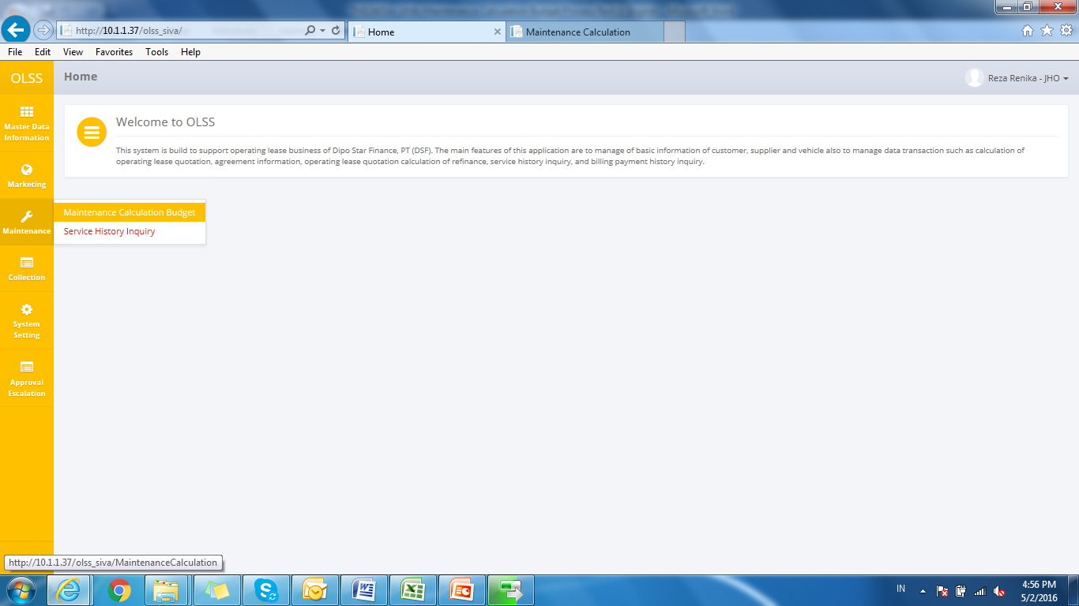

Screen : Maintenance Calculation Budget Menu

1. System will show Maintenance Calculation screen that already recorded in the system. The main page is shown below:

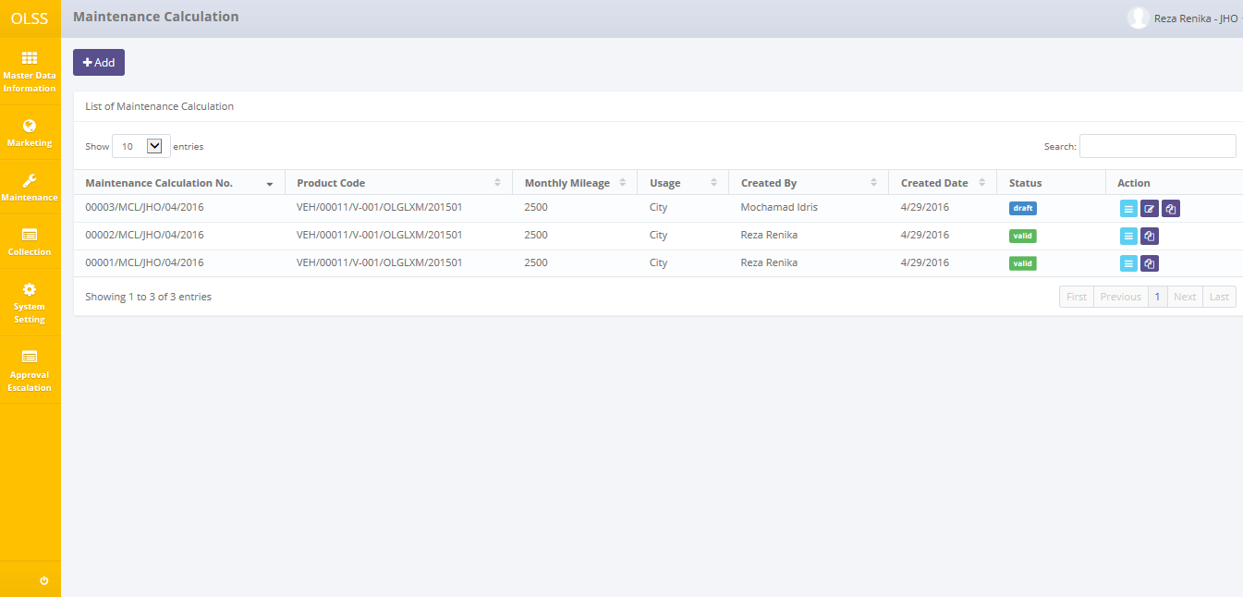

Screen : Maintenance Calculation

User can see information such as:

Maintenance Calculation Number, Product Code, Monthly Mileage, Usage, Created By, Created Date, Status, and Action row.

Maintenance Calculation statuses are divided into 3 types:

1. , maintenance calculation hasn’t been submitted by admin.



1. 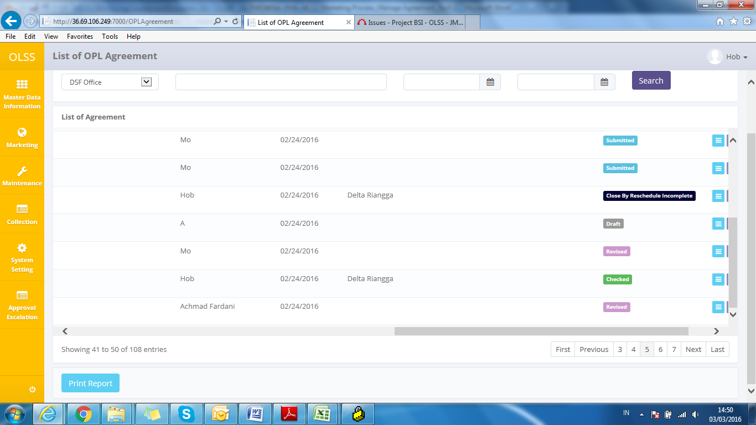, maintenance calculation has been submitted by admin.
2. , maintenance calculation has been validate and can be used for the next processes.

On the Maintenance Calculation Budget screen, there will be five buttons, which are:

* 1. : On top-left screen, click the button to create/add a new maintenance calculation budget.
  2. : In the action column, click the button to modify maintenance calculation budget information.
  3.  : In the action column, click the button to view detail of maintenance calculation budget information.
  4. : In the action column, click the button to copy the maintenance calculation budget data.

## Filter and Sort Maintenance Calculation List

To filter the records there are three categories as follows:

1. To sort the record alphabetically by column, user can click  on the column title on the table header.
2. User can select the number of records that want to be showed by picking this feature  on the screen. If the records have been filtered based on number, the amount of records that will be shown is the same as the selected number.
3. User can filter the records by entering the keywords on the search field with shown below:



Screen : Search Field

## Add a New Master Data Maintenance Category and Maintenance Item

To create Maintenance Calculation Budget required master data Maintenance Category and Maintenance Item that can be added on a separate menu.

* + 1. **Maintenance Category**

Open Maintenance Category menus by clicking ‘Maintenance Category’ on the list of Master Data Information modul shown below.

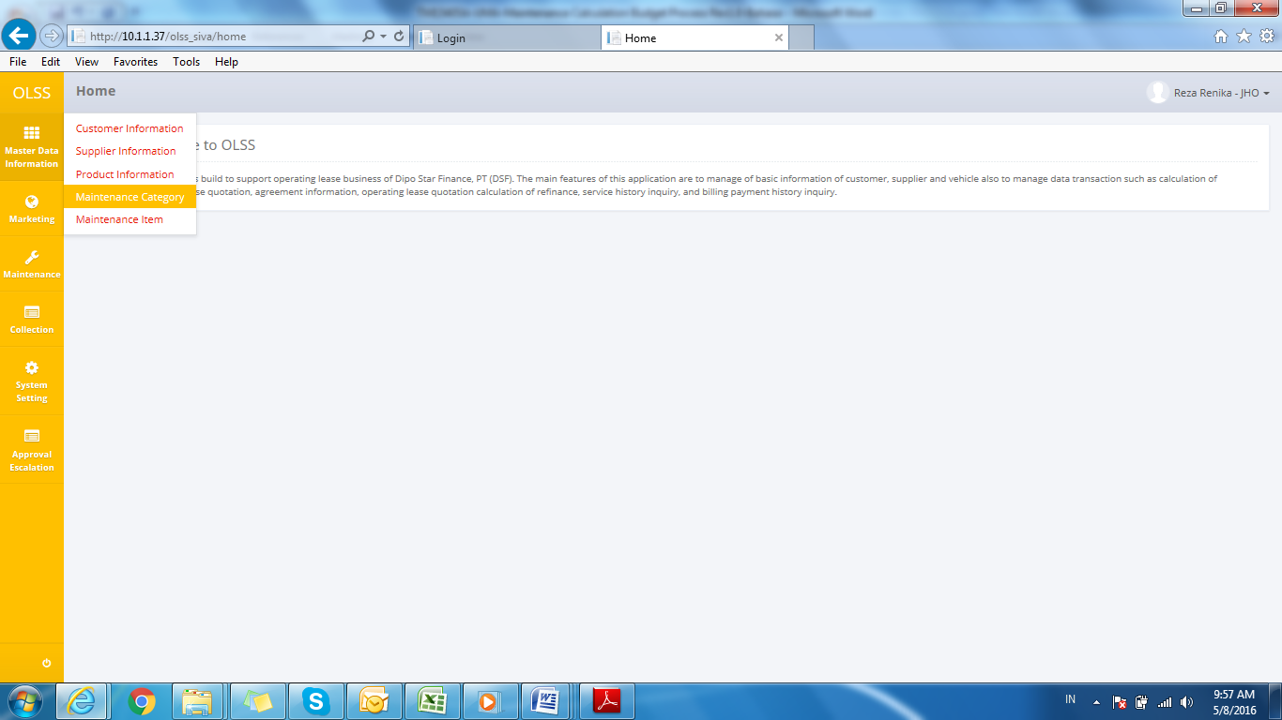

Screen : Maintenance Category Menu

Add Maintenance Category information by clicking button , then fill Category Name field (mandatory) with maintenance category such as Regular, Irregular, etc; and Remarks (if any). System will notified if it failed or success after clicking Save as Draft or Submit button. Status will be changed to Draft or Submitted.

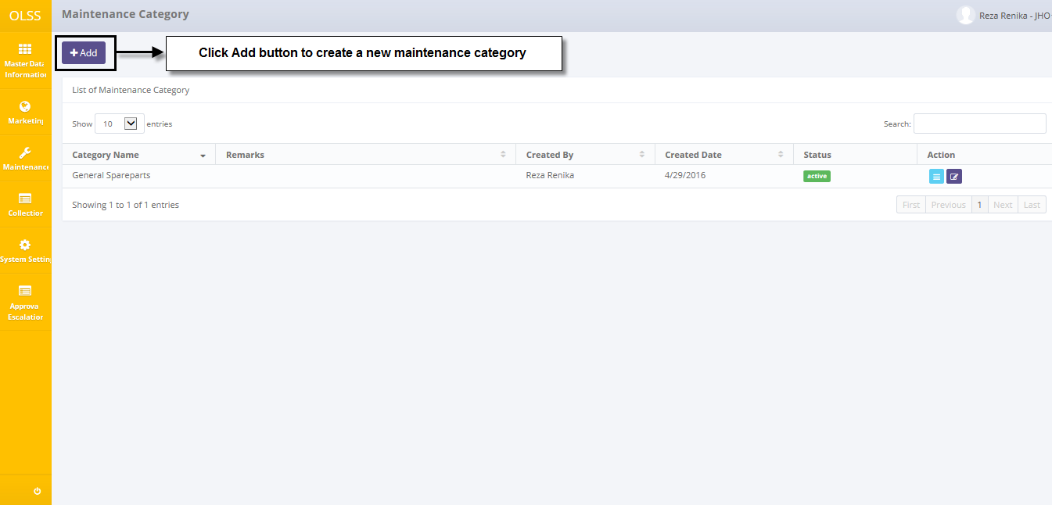

Screen : Navigate to Add Maintenance Category

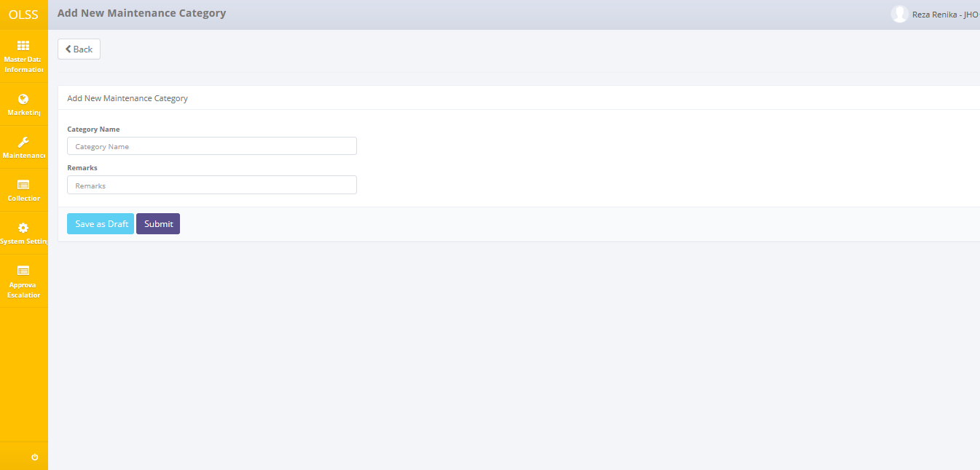

Screen : Screen of Add New Maintenance Category

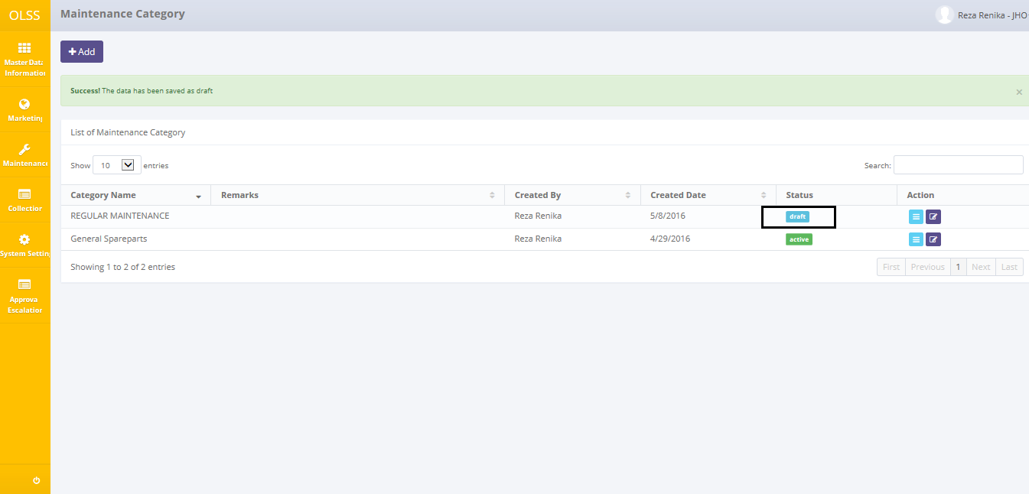

Screen : Notification Success after Save as Draft



Screen : Notification Success after Submit

Update Maintenance Category information by clicking button  on the record with status Draft or Submitted, then modify the maintenance category on Category Name and/or Remarks field. System will notified if it failed or success after clicking Save Changes button.

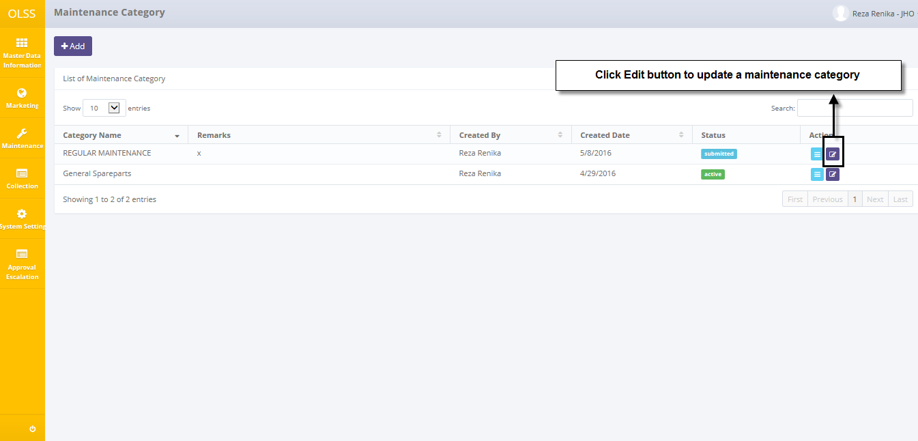

Screen : Navigate to Edit Maintenance Category

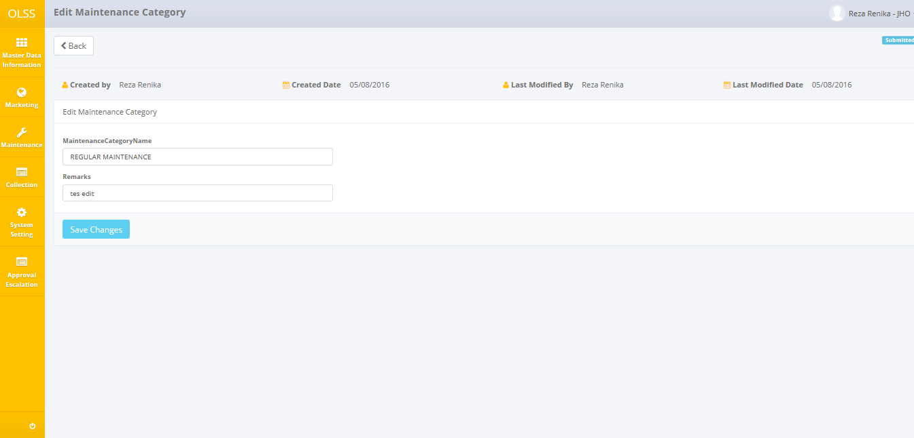

Screen : Screen of Edit Maintenance Category with status Submitted



Screen : Notification Success after Save Changes

Maintenance Category can be used to Maintenance Calculation budget if the status change to Active. To change the status from Submitted to Active by clicking button  on the right side of the records, then click button  on Maintenance Category Detail page and the records can’t be updated again. System will notified if it failed or success after clicking the button.

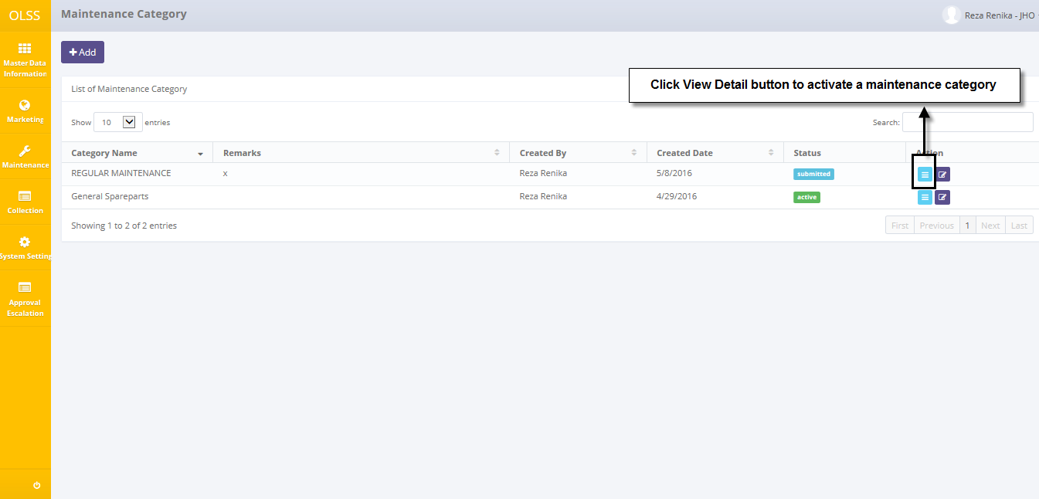

Screen : Navigate to View Detail Maintenance Category

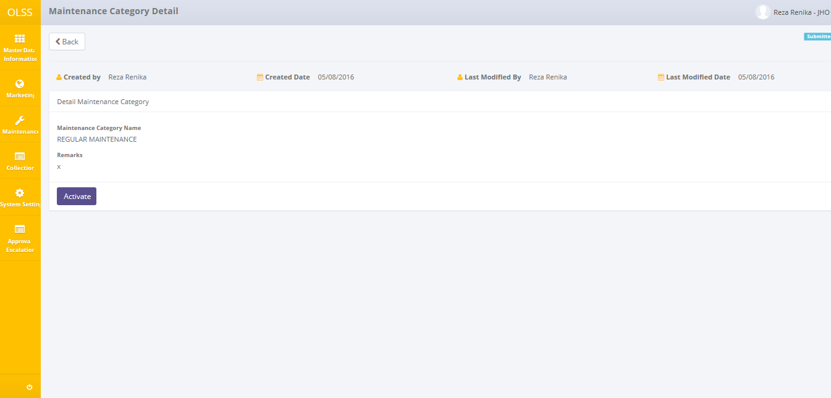

Screen : Screen of Maintenance Category Detail with status Submitted



Screen : Notification Success after Activate

If Maintenance Category is not used, then it can be deactivate by clicking button  on the right side of the records, then click button  on Maintenance Category Detail page. If you want to update the information after activate, it is necessary to change status becomes Draft first by clicking button , then click button  on Maintenance Category Detail page. System will notified if it failed or success after click button Deactive or Set to Draft.

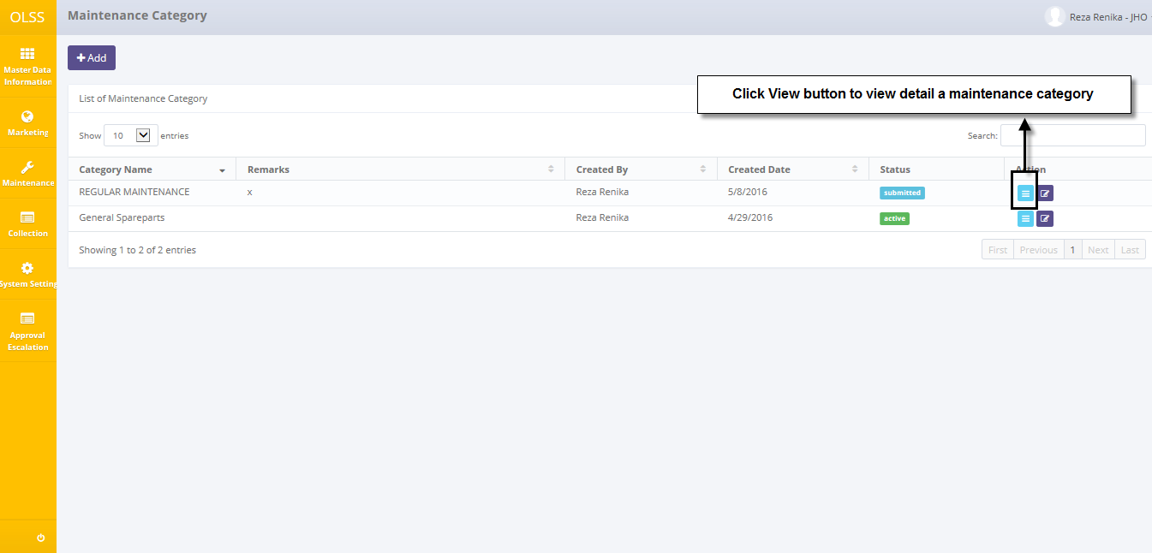

Screen : Navigate to View Detail Maintenance Category

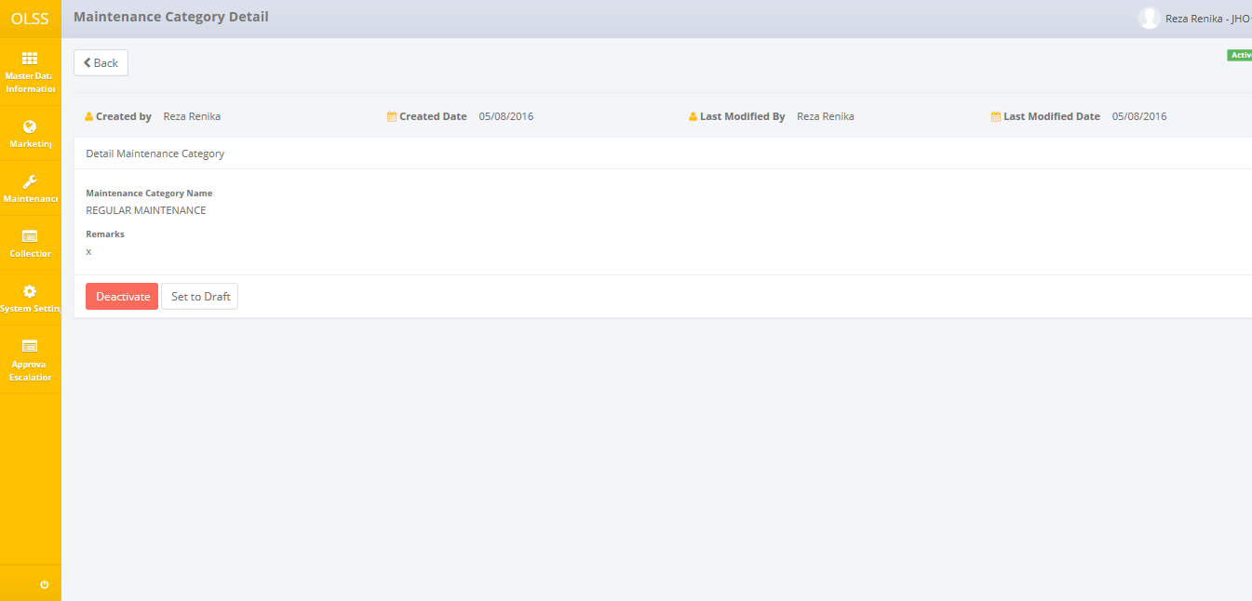

Screen : Screen of Maintenance Category Detail with status Active



Screen : Notification Success after Deactivate



Screen : Notification Success after Save as Draft

* + 1. **Maintenance Item**

Open Maintenance Item menus by clicking ‘Maintenance Item’ on the list of Master Data Information modul shown below.

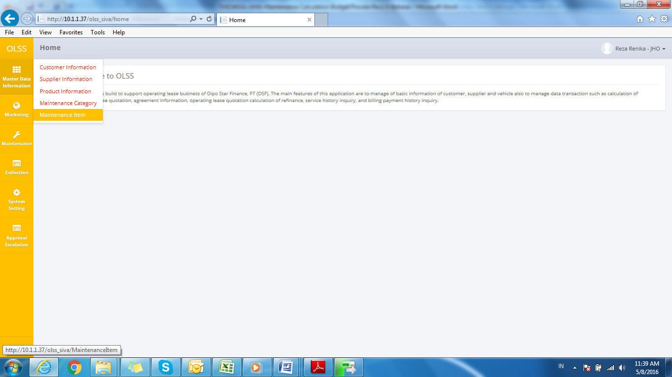

Screen : Maintenance Item Menu

Add Maintenance Item information by clicking button , then fill Item Code field (mandatory) with item which will be in maintenance; and Item Name (if any). System will notified if it failed or success after clicking Save as Draft or Submit button. Status will be changed to Draft or Submitted.

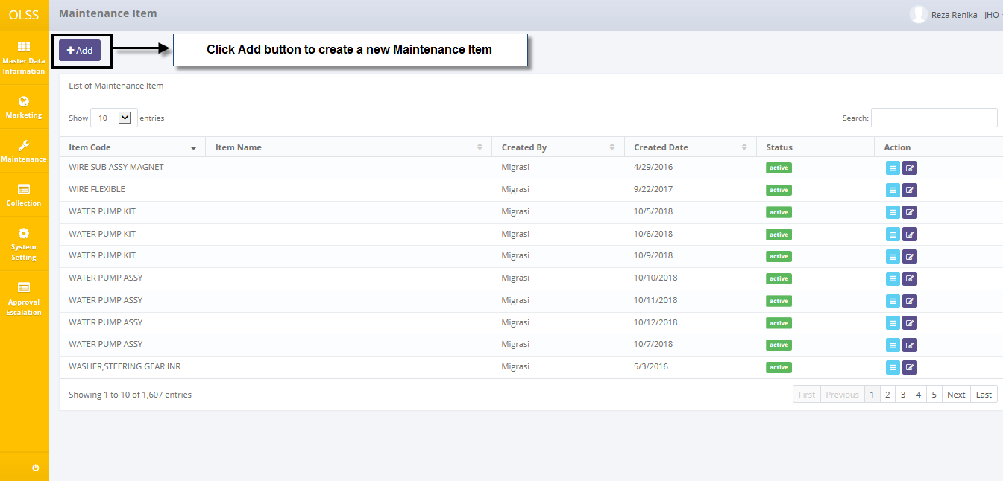

Screen : Navigate to Add Maintenance Item

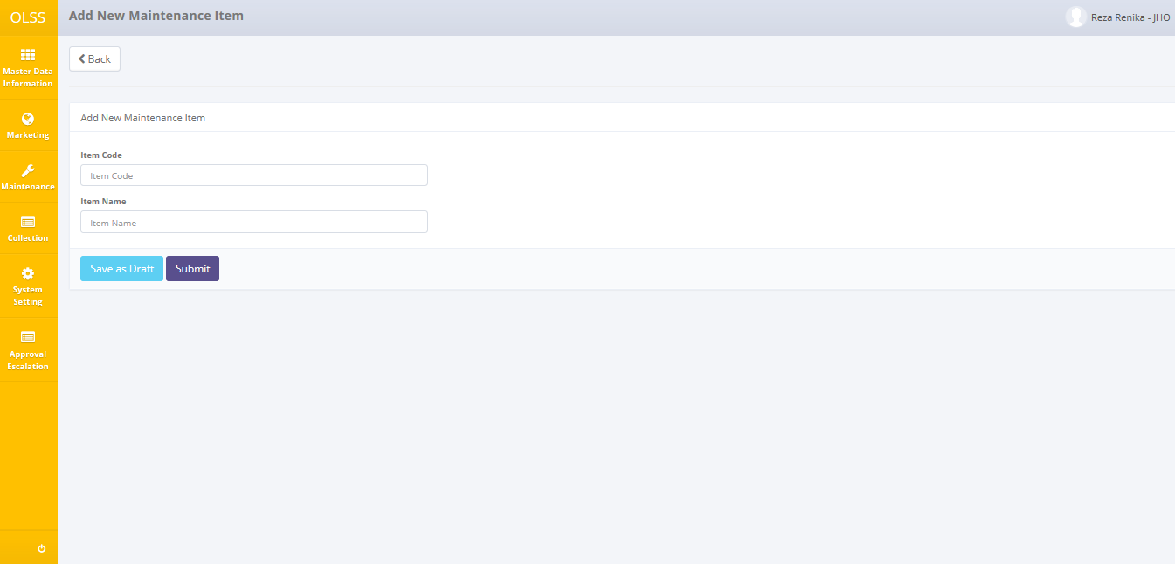

Screen : Screen Add New Maintenance Item



Screen : Notification Success after Save as Draft



Screen : Notification Success after Submit

Update Maintenance Item information by clicking button  on the record with status Draft or Submitted, then modify the maintenance item on Item Code and/or Item Name field. field. System will notified if it failed or success after clicking Save Changes button.

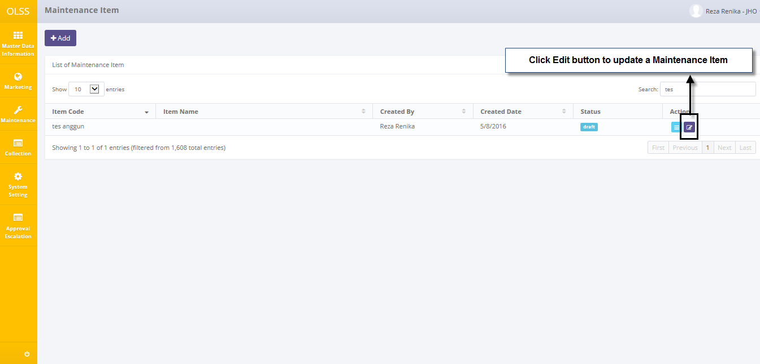

Screen : Navigate to Edit Maintenance Item

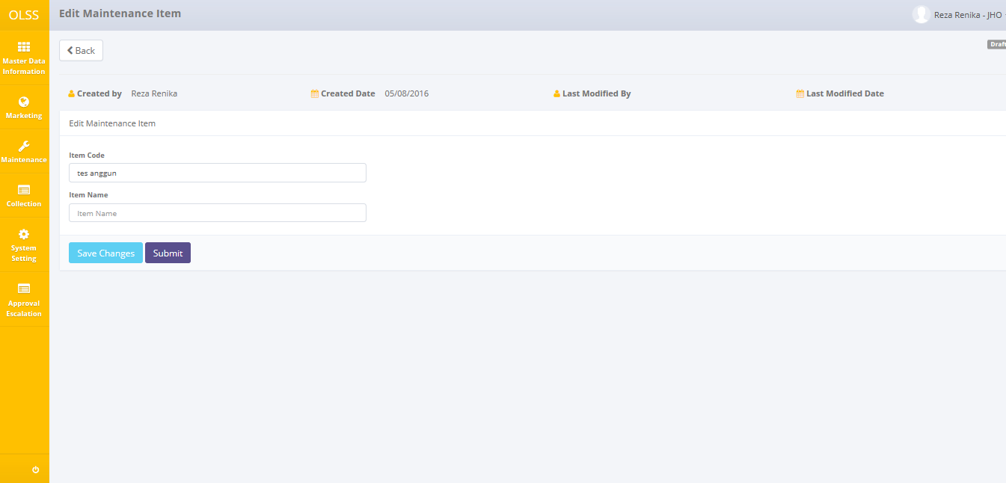

Screen : Screen of Edit Maintenance Item with status Draft



Screen : Notification Success after Save Changes

Maintenance Item can be used to Maintenance Calculation budget if the status change to Active. To change the status from Submitted to Active by clicking button  on the right side of the records, then click button  on Maintenance Item Detail page and the records can’t be updated again. System will notified if it failed or success after clicking the button.

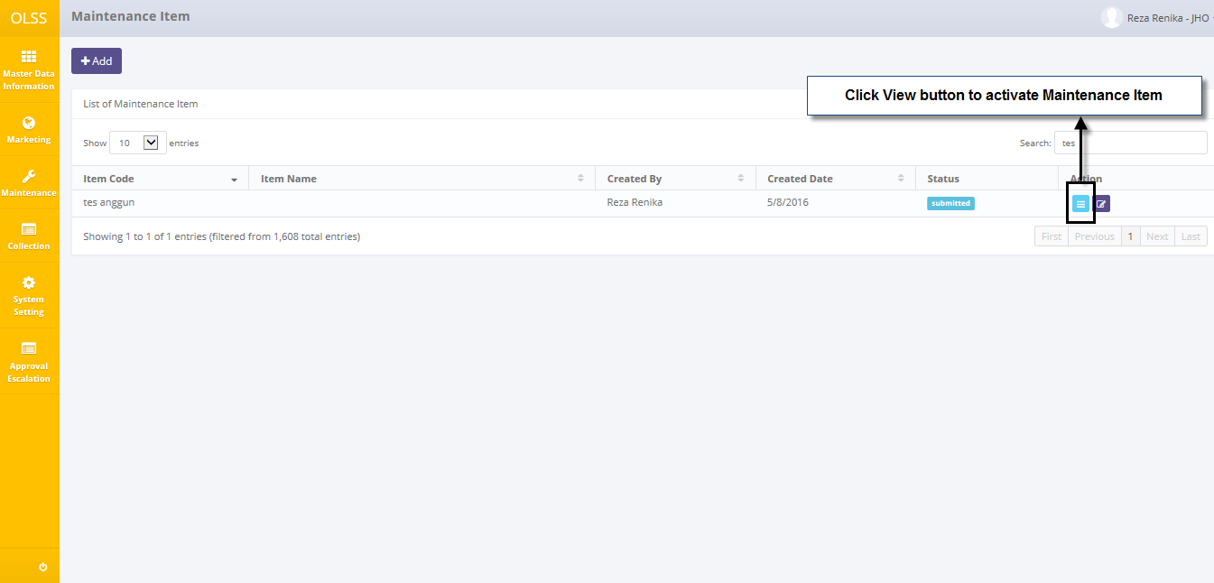

Screen : Navigate to View Detail Maintenance Item

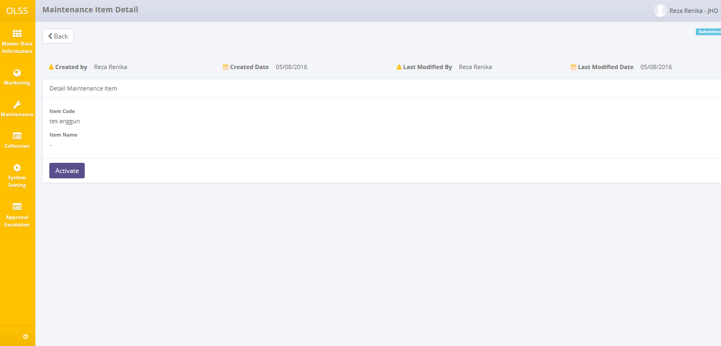

Screen : Screen of Maintenance Item Detail with status Submitted



Screen : Notification Success after Activate

If Maintenance Item is not used, then it can be deactivate by clicking button  on the right side of the records, then click button  on Maintenance Item Detail page. If you want to update the information after activate, it is necessary to change status becomes Draft first by clicking button , then click button  on Maintenance Item Detail page. System will notified if it failed or success after click button Deactive or Set to Draft.

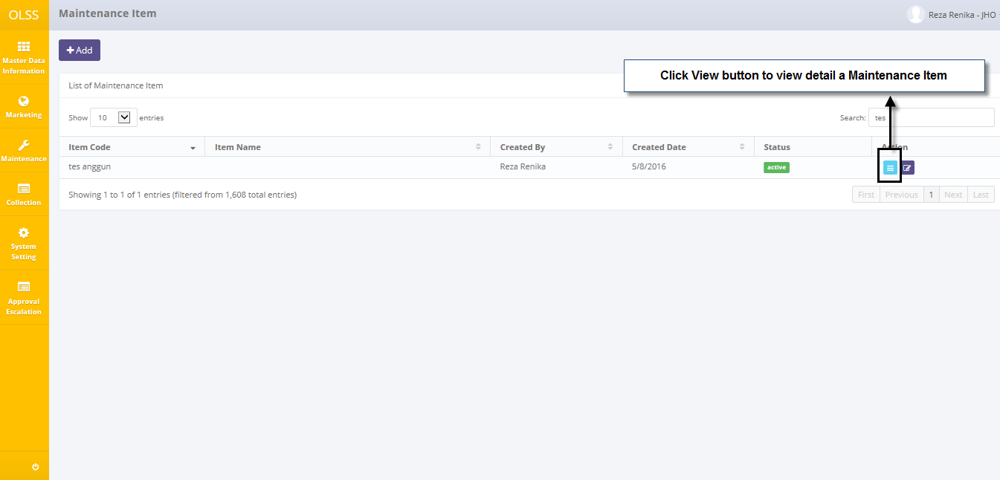

Screen : Navigate to View Detail Maintenance Item

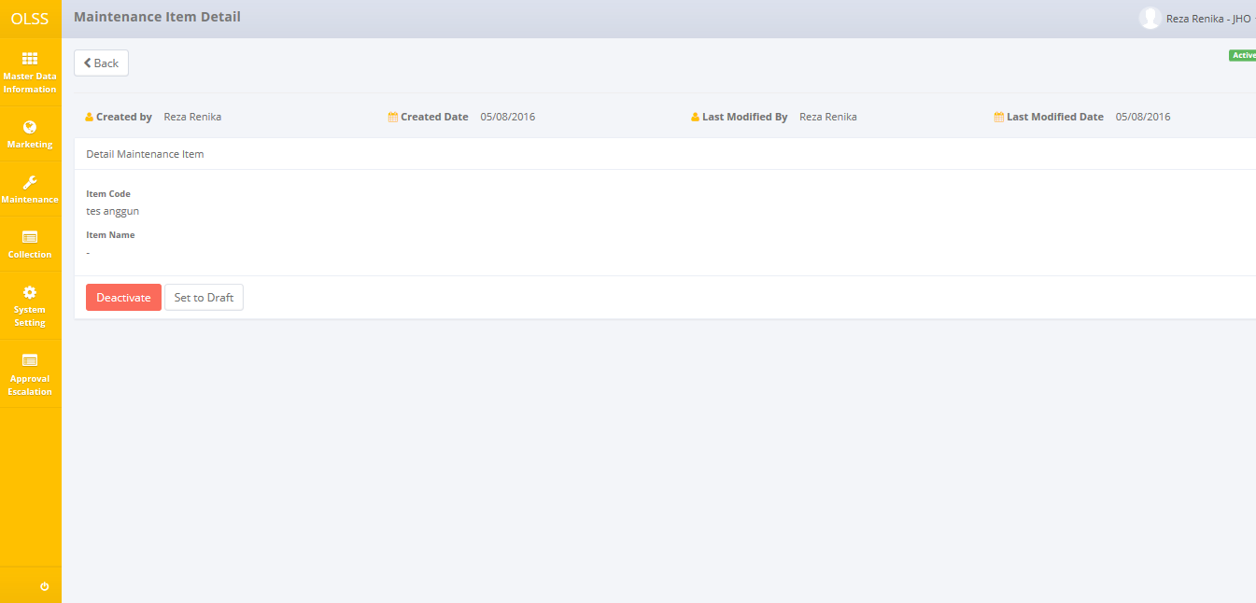

Screen : Screen of Maintenance Item Detail with status Active



Screen : Notification Success after Deactivate



Screen : Notification Success after Save as Draft

## Add a new Maintenance Calculation Budget

To add maintenance calculation, find and click Add button on top of the Maintenance Calculation Screen.

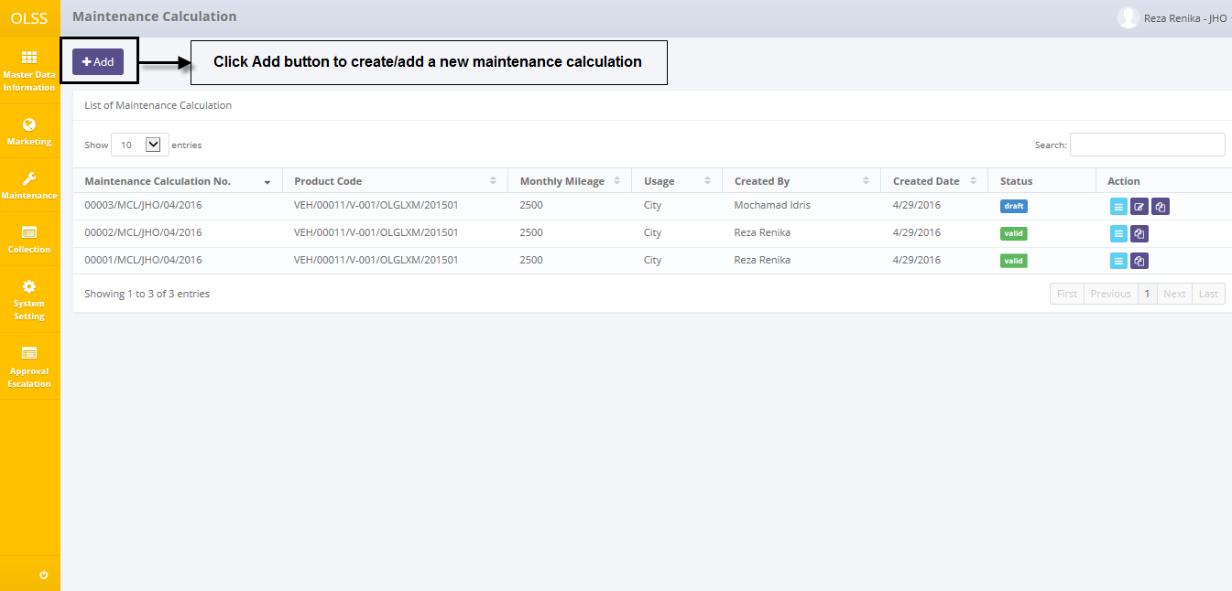

Screen : Navigate to Add Maintenance Calculation Budget

System will show Add New Maintenance Calculation screen shown below:

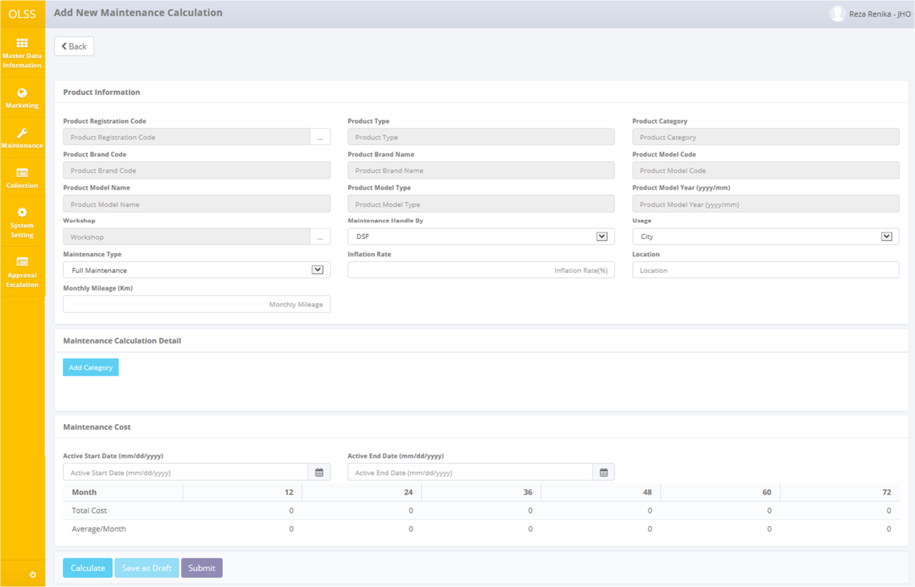

Screen : Screen of Add New Maintenance Calculation

Once the maintenance calculation creation screens above open, user has to fill information on the blank field. The fields are:

1. Product Information:
   1. Product Registration Code: Select product code. Selecting product code will automatically load up product information (Product Type, Product Category, Product Brand Code, Product Brand Name, Product Model Code, Product Model Name, Product Model Type, and Product Model Year).
   2. Workshop: Select workshop that perform maintenance for the unit.
   3. Maintenance Handle By: pick the maintenance handled by DSF or Third Party.
   4. Usage: pick usage City or Site.
   5. Maintenance Type: select maintenance type (Full Maintenance or Customer Service Desk).
   6. Inflation Rate: fill with percentage of inflation.
   7. Location: fill with location of maintenance process.
   8. Monthly Mileage (Km): fill with number of kilometre monthly mileage.
2. Maintenance Calculation Detail - Add Category *(see screen 36 below)*
3. Maintenance Cost:
   1. Active Start Date (mm/dd/yyyy): select current date.
   2. Active End Date (mm/dd/yyyy): select end date of maintenance calculation budget.

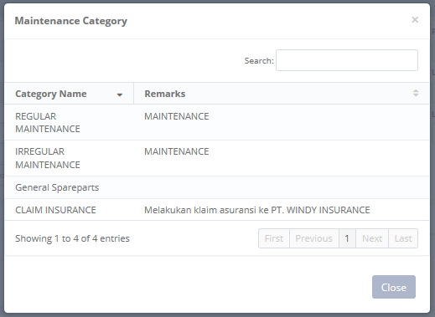

Screen : Screen of Maintenance Category after Add Category

Once the Maintenance Category pop-ups open, user has to select the maintenance category which has been register in master menus. Then click category that have been selected to display probability and add item.

 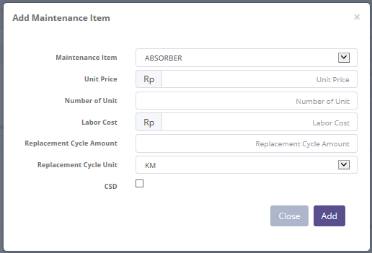

Screen : Screen of Add Maintenance Item after Add Item

Once the Add Maintenance Item pop-ups open, user has to fill information on the blank field and add the data. The fields are:

1. Maintenance Item: select the maintenance item.
2. Unit Price: input unit price that will be maintained.
3. Number of Unit: input number of unit that will be maintained.
4. Labor Cost: input amount of labor cost.
5. Replacement Cycle Amount: input number/amount of replacement cycle by kilometre or month.
6. Replacement Cycle Unit: pick KM or Month.
7. CSD: check if the maintenance type CSD.

There are four buttons that will be displayed on the Add New Maintenance Calculation screen as follows:

1. , on the top-left corner of the screen, to go to previous screen.
2. , on the bottom-left corner of the screen. Clicking this button will calculate the maintenance cost based on maintenance calculation detail for 12 until 72 month.
3. , on the bottom-left corner of the screen. Clicking this button will made maintenance calculation status changed into Draft.
4. , on the bottom-left corner of the screen. Clicking this button will made maintenance calculation status changed into Submitted.

After the data entered on the screen, user can save the information on the system by clicking **Save as Draft** or **Submit** button if you fix with the data after Calculate the Maintenance Cost.

There are mandatory fields. It can’t leave as blanks. If you leave them blanks, system will notified it after you clicking **Calculate** button.



Screen : Error notification after Calculate

After clicking **Save as Draft** and **Submit** button, system will notified if it success or failed to save data.



Screen : Success notification after Save as Draft



Screen : Success notification after Submit

## Edit a Maintenance Calculation Budget

To edit maintenance calculation budget record, navigate to the Maintenance Calculation screen and click Edit button on the right side of the record with status.

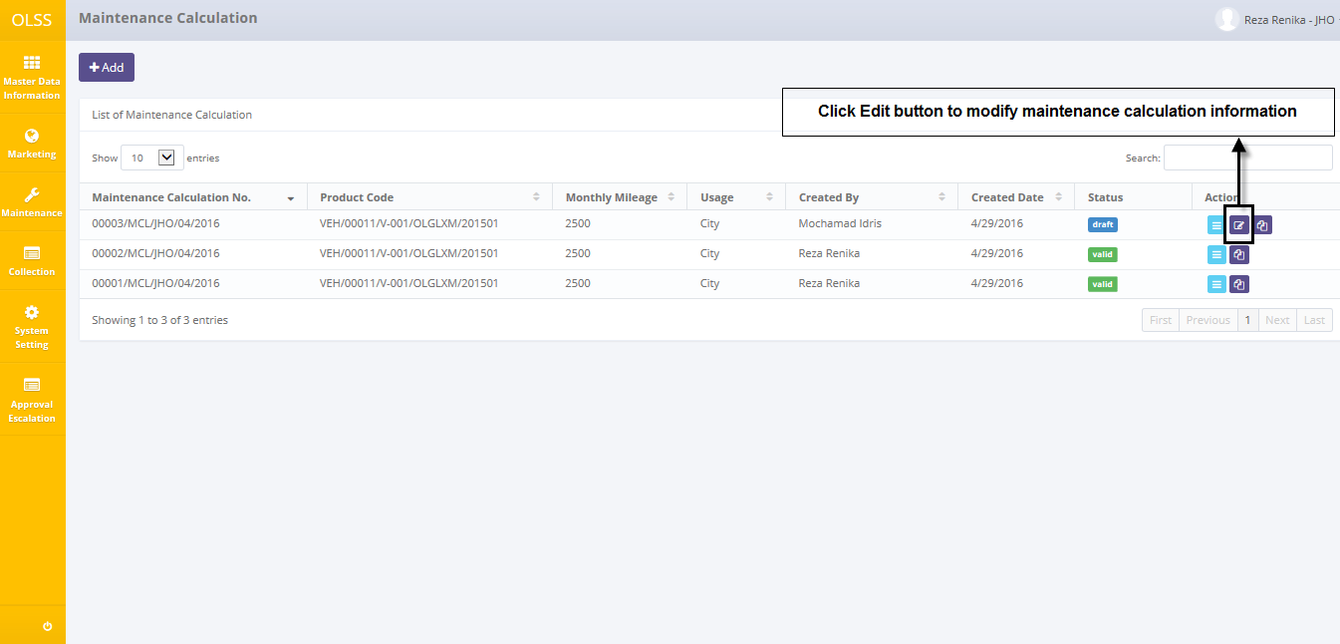

Screen : Navigate to Edit Maintenance Calculation

The screen below is shown after the Edit button is clicked. System will displays the data that you has been entered before.

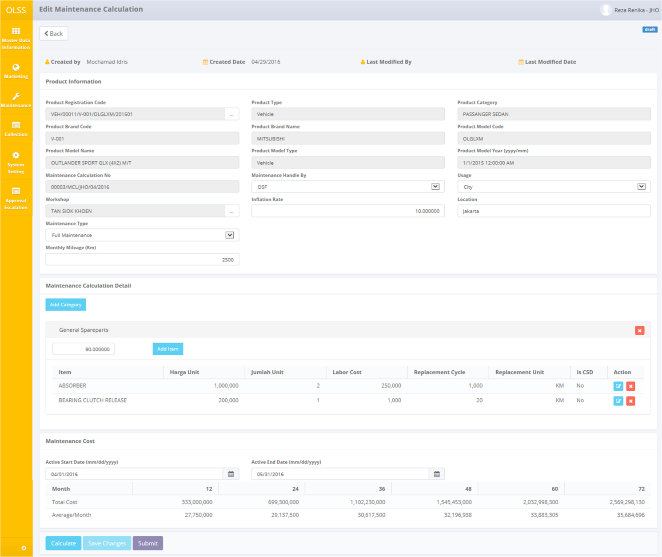

Screen : Screen of Edit Maintenance Calculation

Once the Edit Maintenance Calculation screens open, user can edit existed information. There are five buttons that will be displayed on the screen as follows:

1. , on the top-left corner of the screen, to go to previous screen.
2. , on the bottom-left corner of the screen. Clicking this button will calculate the maintenance cost based on maintenance calculation detail for 12 until 72 month.
3. 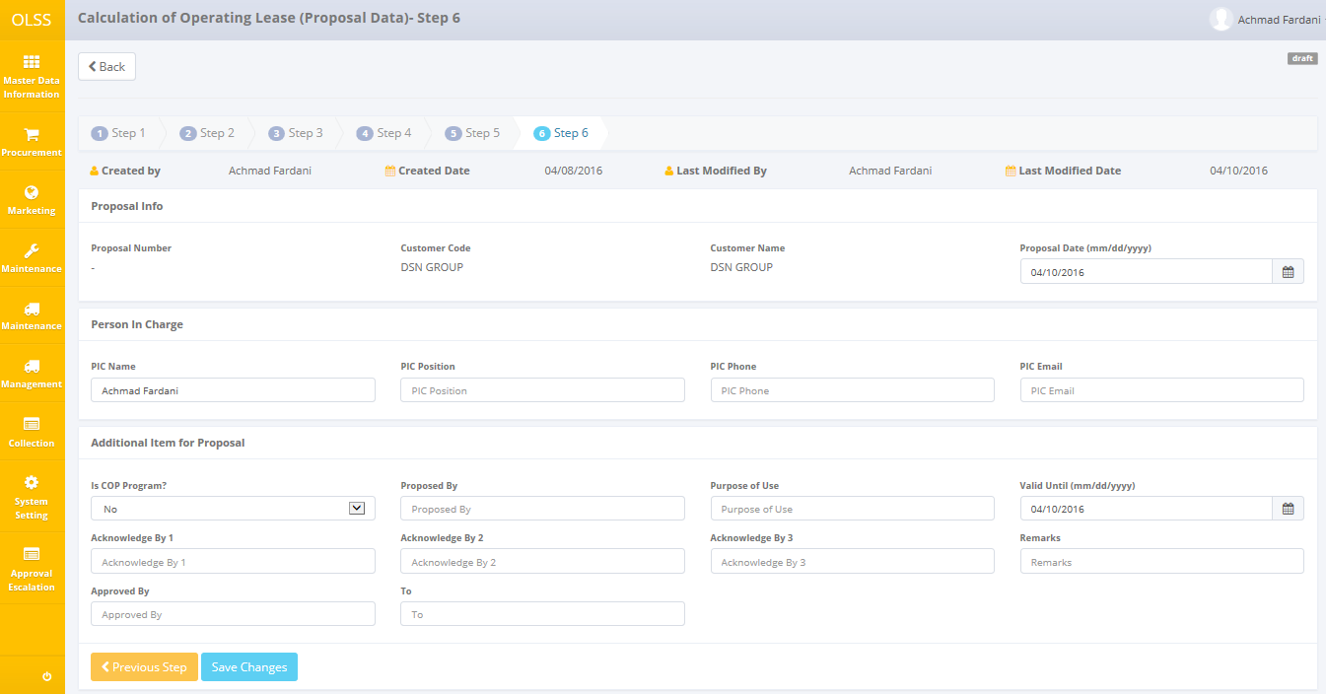, on the bottom-left corner of the screen. Clicking this button will update the maintenance calculation.
4. , on the bottom-left corner of the screen. Clicking this button will made calculation status changed into Submitted.

If data already changed on the screen, user can save data on the system by clicking **Save Changes** button, then click **Submit** button. There are mandatory fields. It can’t leave as blanks. If you leave them blanks, system will notified it after you clicking **Calculate** button.



Screen : Error notification after Calculate

After clicking **Save Changes** or **Submit** button, system will notified if it success or failed to save or submit a data. You also have a **Back** button, which redirect you to the previous page.



Screen : Success notification after Save Changes



Screen : Success notification after Submit

## View Detail Maintenance Calculation Budget

To view the records, you can select a record from the list on Maintenance Calculation page by clicking the action button , on the rightmost column.

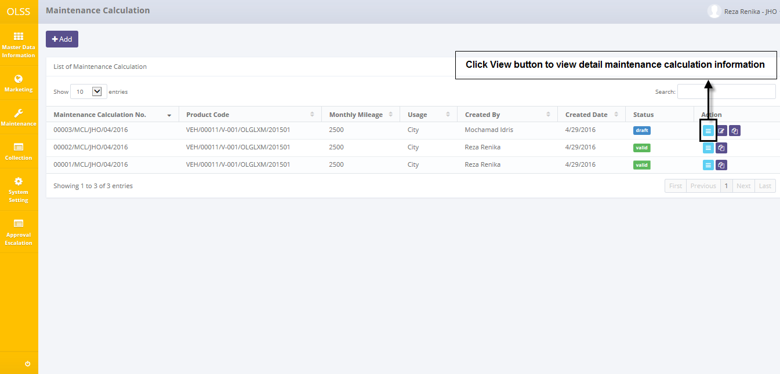

Screen : Navigate to View Detail Maintenance Calculation

Screen will show view detail maintenance calculation screen shown below:

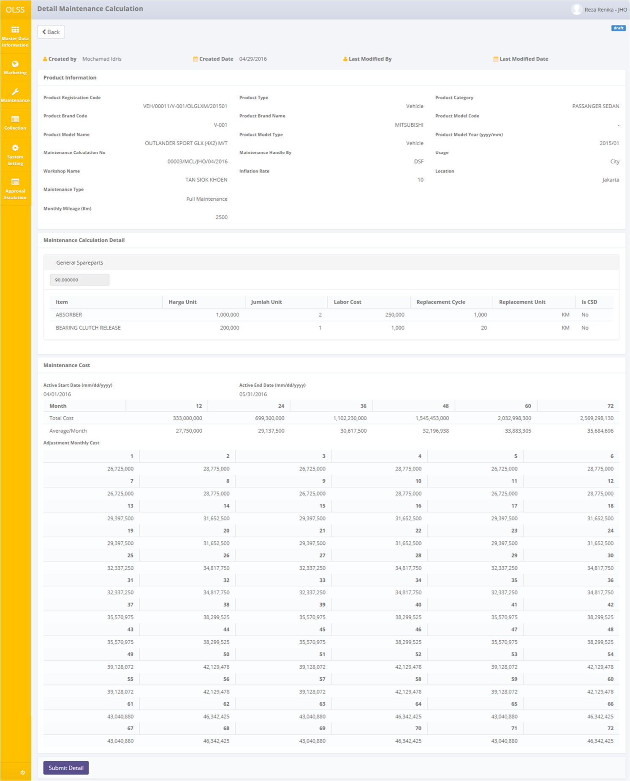

Screen : Screen View Detail Maintenance Calculation

User can check the records but the records cannot be edited. Here you can see the detail information related with maintenance calculation data. There are five buttons that will be displayed on the screen as follows:

1. , on the top-left corner of the screen, to go to previous screen.
2. , on the bottom-left corner of the screen. Clicking this button will made maintenance calculation status changed into Submitted. This button only displayed if maintenance calculation status still Draft.
3. , on the bottom-left corner of the screen. Clicking this button will made maintenance calculation status changed into Valid. This button only displayed if maintenance calculation status still Submitted.
4. , on the bottom-left corner of the screen. Clicking this button will made maintenance calculation status changed into Draft. This button only displayed if maintenance calculation status still Submitted.
5. , on the bottom-left corner of the screen. Clicking this button will made maintenance calculation status changed into Invalid. This button only displayed if maintenance calculation status still Valid.

## Copy – Paste Maintenance Calculation Budget Data

To copy the records, you can select a record from the list on Maintenance Calculation page by clicking the action button Copy, on the rightmost column.

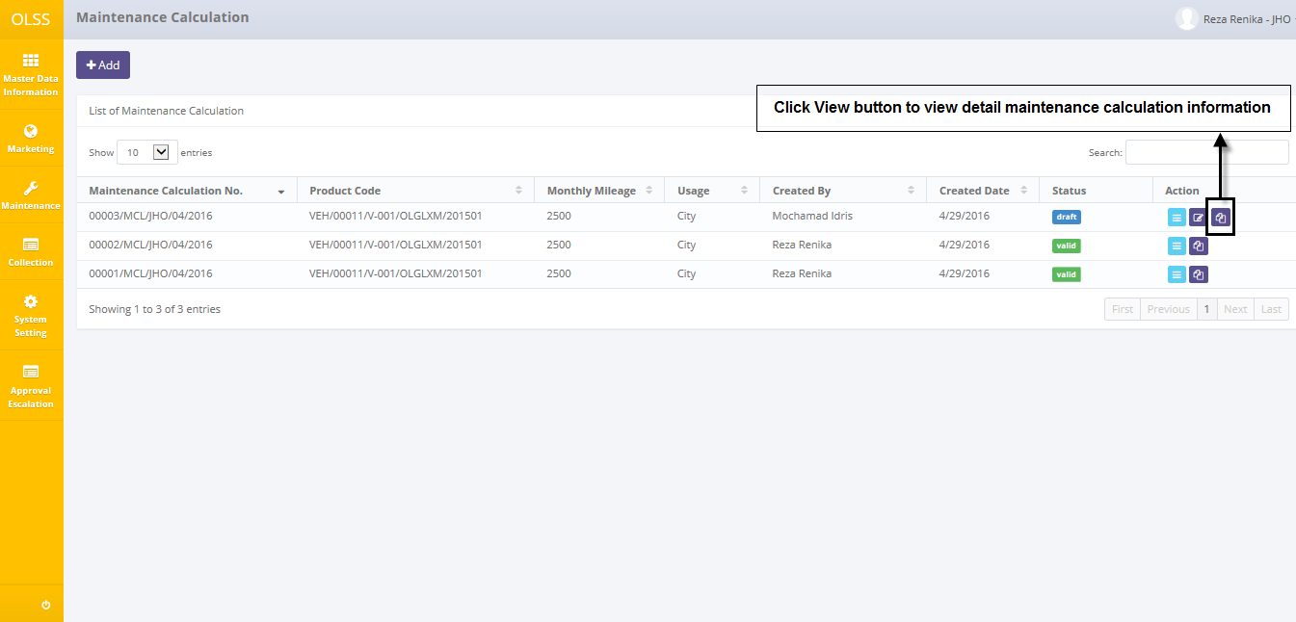

Screen : Navigate to Copy Maintenance Calculation Data

Screen will show Edit Maintenance Calculation screen with success notification shown below after copy the data:

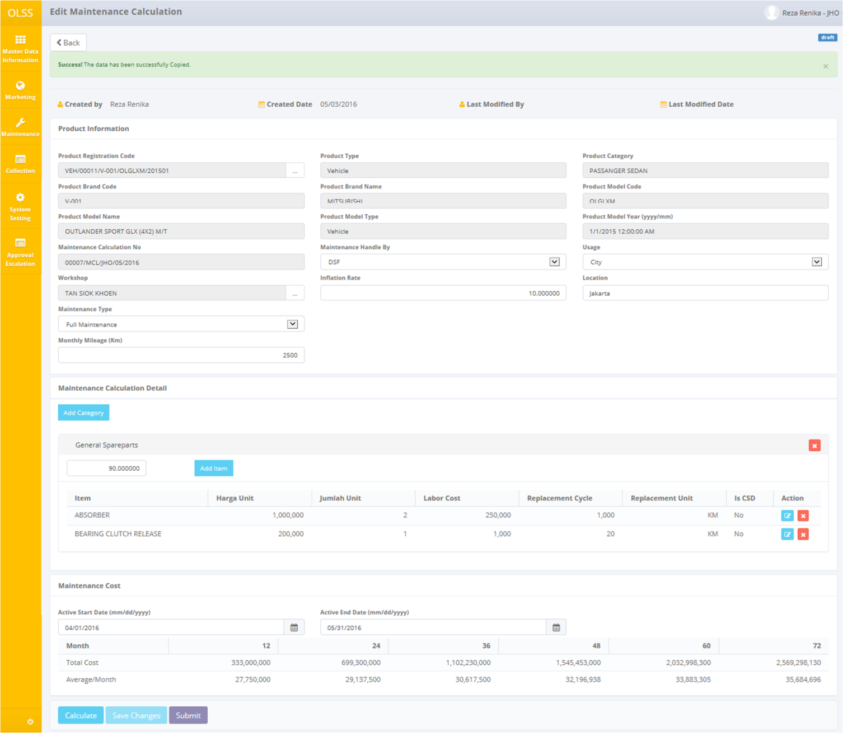

Screen : Copy Maintenance Calculation Data

If data already changed on the screen, user can save data on the system by clicking **Save Changes** button, then click **Submit** button. There are mandatory fields. It can’t leave as blanks. If you leave them blanks, system will notified it after you clicking **Calculate** button.



Screen : Error notification after Calculate

After clicking **Save Changes** or **Submit** button, system will notified if it success to save or submit a data and also create a new maintenance calculation budget. You also have a **Back** button, which redirect you to the previous page.

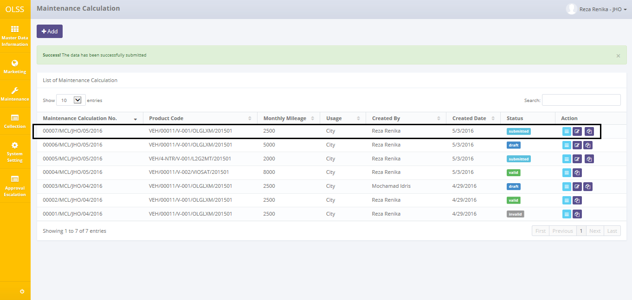

Screen : New List of Maintenance Calculation Data



Screen : Success notification after Save Changes



Screen : Success notification after Submit